Setting of Adobe PDF printer for new EXCEL FORMS which will create PDF File when E-mail option selected.

This document explains how to change the port settings and Preferences settings of Adobe PDF printer.

- Port Setting

Goto -> Start > Setting > Printer & Faxes

Right Click on Adobe PDF print driver -> Click on properties ->

Under Ports Tab -> Click on Add port

Following screen will show up

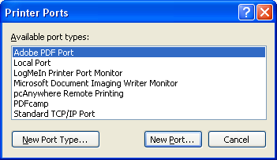

Select Adobe PDF port and Click on New Port
Browse to c:\tmp
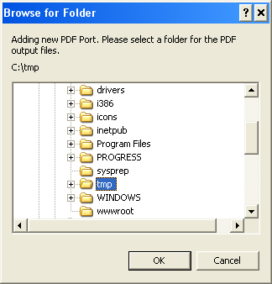

Click on Ok -> Close

- Setting Printer Preferences
Goto -> Start > Setting > Printer & Faxes

Right Click on Adobe PDF print driver -> Click on properties ->

Under General Tab Click on Printer Preferences.

Make sure all the settings are as shown below.

